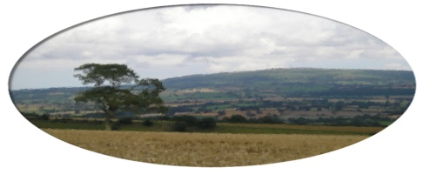
Munslow Parish Council
MINUTES

Minutes of the meeting held on Thursday 2nd July 7.30 pm via SKYPE.

Present ; Cllrs - Barbara Archer (Chair) Linda Charie , ,Mike Kelly , David Marston , Val Fotheringham .
Clive Leworthy (Clerk)

The Chair welcomed everyone to the first virtual meeting of Munslow PC.

- Public Forum (limited to 15 minutes) members of the public may raise any issues with the Council during the public forum but not during the Council meeting unless invited to do so by the Chairman. Members of the public can join the meeting via SKYPE but cannot participate in the meeting once the public session is completed. Contact the Clerk for further info on joining the meeting.

No public had requested to attend the meeting.

2. Apologies for absence. Buster Evans - Cllr Motley – Chris Meeson

3. Declarations of Interest. -None

- Approval of the minutes from meeting held on 5th March 2020 – Approved Prop Linda Charie 2nd David Marston
- Matters Arising from those minutes that are not covered on the Agenda – The Chair reported that the CCEG had cleared foliage and tied up the car park – The 30mph sign blown over in the storm was now restored. The traffic engineering meeting was on hold due to Covid 19. Mike Kelly commented that speeding had increased since lockdown restrictions had been eased.

6. Vacancy -To confirm the posting of a Notice to Co Opt a Councillor , with applicants to email the Clerk expressing an interest by 21st August 2020 with Co-Option to take place at 3rd Sept Meeting. Notice posted on noticeboards and website. Candidates would be asked to submit a short statement and this would then be considered at the Sept meeting.
7. Reports
(a) Chairman – Smartwater Update. All kits now delivered via post and hand delivery. The Chair had visited suitable locations around the parish and had circulated a map for Council to review where signs would be located. This was approved by Council and Chair would now inform Police.
(b) Cllr Cecelia Motley – Reports circulated via email

8. Finance
(a) Consider the accounting statement 2020/21 to date.
(b) Consider payments for approval.
Clerk’s Salary June = £152.47
HMRC = £38.00
SALC = £213.42
(c) To consider and approve the Annual Governance and Accounts Review 2019/20 (AGAR) Council reviewed the AGAR for submission to the external auditor. Approved Pop Linda Charie 2nd Mike Kelly.

9. Planning Matters
(a) Consider any new applications

NONE

Mike Kelly thanked the Clerk & Chair for keeping Council advised and updated during the Covid 19 period.

Next meeting 3rd September 2020.

